Applied Hyperspectral Imaging Services

Post-Flight Aerial Acquisition and Calibration Report

  - 30 Oct 2018

Installation and Calibration
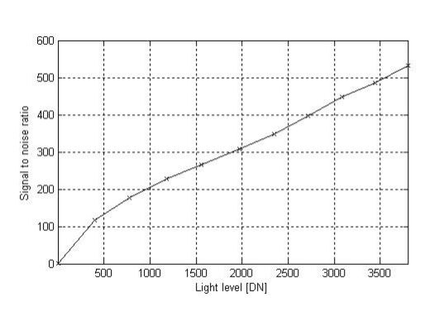
On 28 Aug 2018 the airborne hyperspectral imaging system, which consisted of an AISA Eagle II VNIR Hyperspectral Imaging Sensor (400 – 1000 nm spectral range), an OxTS Survey+ GPS/IMU, and a flight computer, was installed by Galileo Group Inc. (Galileo) scientist Dr. Thorsten Mewes in a specially modified Cessna 172 aircraft. The sensor is annually calibrated using Galileo’s integrating sphere and radiative lamps. Appendix B contains graphs of the sensor’s radiometric calibration coefficient and radiance sensitivity. Below is a graph of the sensor’s Signal to Noise Ratio (SNR).

Figure 1: AISA Eagle SNR Curve

After completing the installation, Dr. Mewes then calculated a lever arm correction based on the installation geometry of the sensor system and the dual GPS antennas equipped on top of the aircraft. This information was then used to configure and calibrate the GPS/IMU using manufacturer software. A successful ground test of the entire system was then performed to ensure all systems were in good working order. Then, the pilot and sensor operator John Merrill transited to the Richard I. Bong Airport in Superior, WI. The aircraft and aircrew arrived safely in Superior, WI on 29 Aug 2018 and prepared to start data collection the next day.

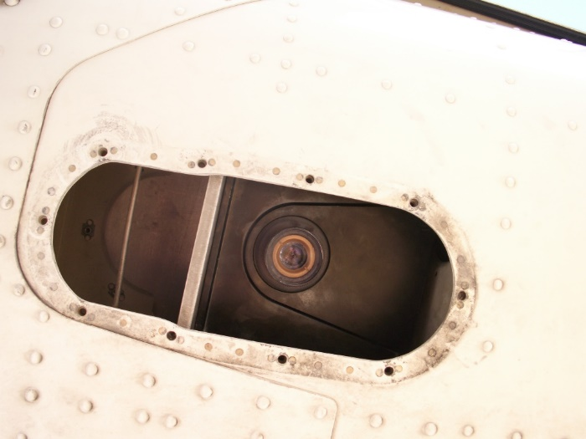
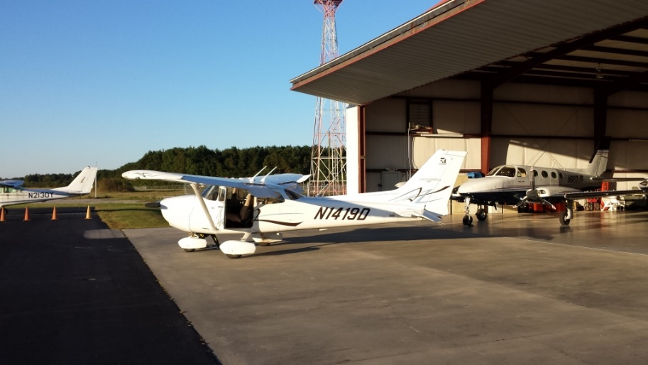

Image 2: Bottom View of Aircraft Camera Port and Sensor Lens
Image 1: Cessna 172 Aircraft

Aerial Data Acquisition
Clear skies allowed aerial data acquisition to begin on 30 Aug 2018. Using manufacturer control and collection software, Mr. Merrill configured the sensor system into 128 spectral bands with a spectral resolution of approximately 4.6 nm. Integration time for all imagery was set to 12ms. Flight altitude for all six sites was set at 4500ft Above Ground Level (AGL) in order to produce 1m Ground Sampling Distance (GSD) for all pixels in the airborne hyperspectral imagery. Sensor frame rate was determined by aircraft speed which varied due to high winds aloft. The following table shows the frame rates used at each speed:

Aircraft Speed (Knots) | 90 | 100 | 110
Sensor Frame Rate (frames per second) | 50 | 56 | 62

Aerial data acquisition continued on September 1st, 3rd, 6th and wrapped up on the 9th. In total 136 flight lines were collected including four lines for the boresight calibration and 16 lines were collected twice due to the presence of clouds and shadows in the imagery. There were no problems with the sensor system or aircraft for the duration of collection operations. Once Mr. Merrill finished field processing the data and confirmed 100% coverage with no shadows or clouds and excellent spectral quality, then aerial data acquisition was wrapped up and the aircraft sent back to its home airport. Flight logs for all collection sorties are included at the end of this report as Appendix A. These logs contain all flight parameters and notes from the sensor operator.
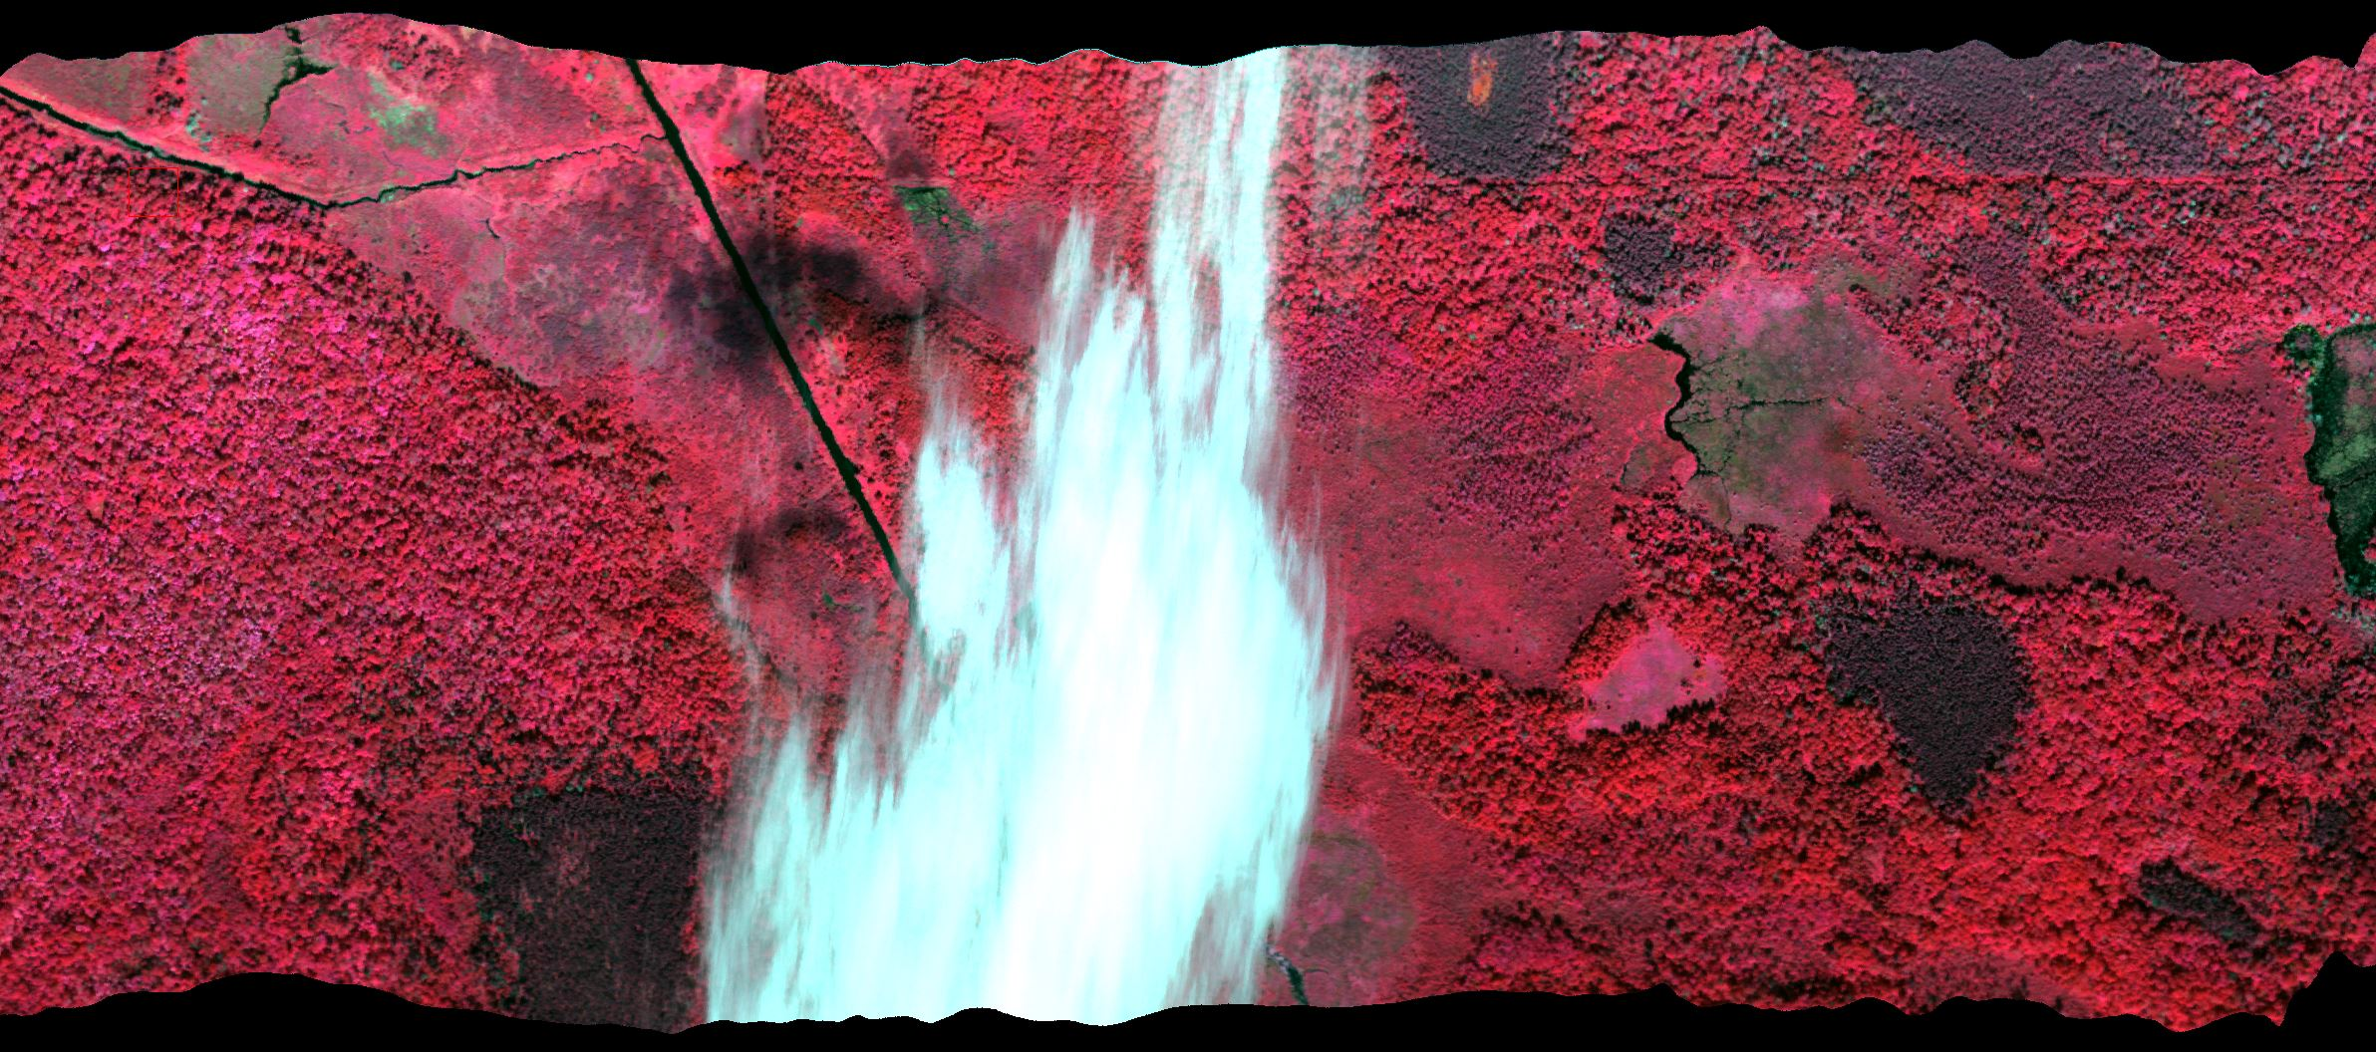

Image 3: Clouds and shadows in flight line 0830-1246

Site 1: Fond du Loc
All 30 of the flight lines for the Fond du Lac site were collected on 30 Aug 2018, but the five northernmost flight lines contained scattered clouds and shadows, so these lines were re-collected on 3 Sept. Below are two mosaic images of the Fond du Lac site. On the left is a Color Infrared (CIR) mosaic with the site boundary as the green polygon. On the right is a Lookup Table (LUT) mosaic that shows the coverage of each individual flight lines as strips of unique color.
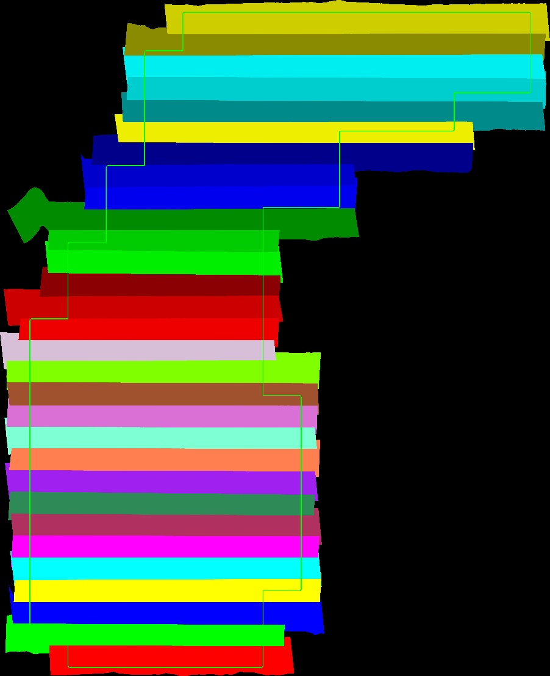
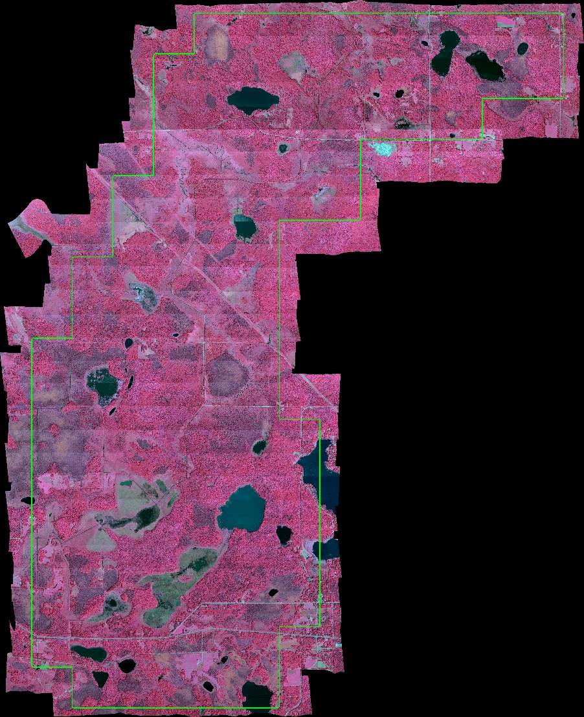
Image 5: Fond du Loc LUT Mosaic
Image 4: Fond du Loc CIR Mosaic

The flight line naming convention is derived from the date and time of collection, so a flight line listed as 0903-1500 was collected on 3 Sept at 3:00PM local time. The following flight lines were used to compose the mosaic for the Fond du Lac site:
- 0903-1455 (Northernmost Flight Line)
- 0903-1500
- 0903-1506
- 0903-1512
- 0903-1518
- 0830-1219
- 0830-1213
- 0930-1209
- 0830-1204
- 0830-1200
- 0830-1154
- 0830-1150
- 0830-1146
- 0830-1142
- 0830-1137
- 0830-1132
- 0830-1127
- 0830-1122
- 0830-1117
- 0830-1113
- 0830-1108
- 0830-1103
- 0830-1058
- 0830-1053
- 0830-1049
- 0830-1044
- 0830-1038
- 0830-1033
- 0830-1029
- 0830-1023 (Southernmost Flight Line)

Site 2: St. Louis River Estuary
The St. Louis River Estuary site was collected over two days. On 1 Sept 2018, 18 lines were collected with four of them containing shadows and clouds. These four lines and the remaining 3 lines were collected on 3 Sept.
- 0903-1544 (Northernmost Line)
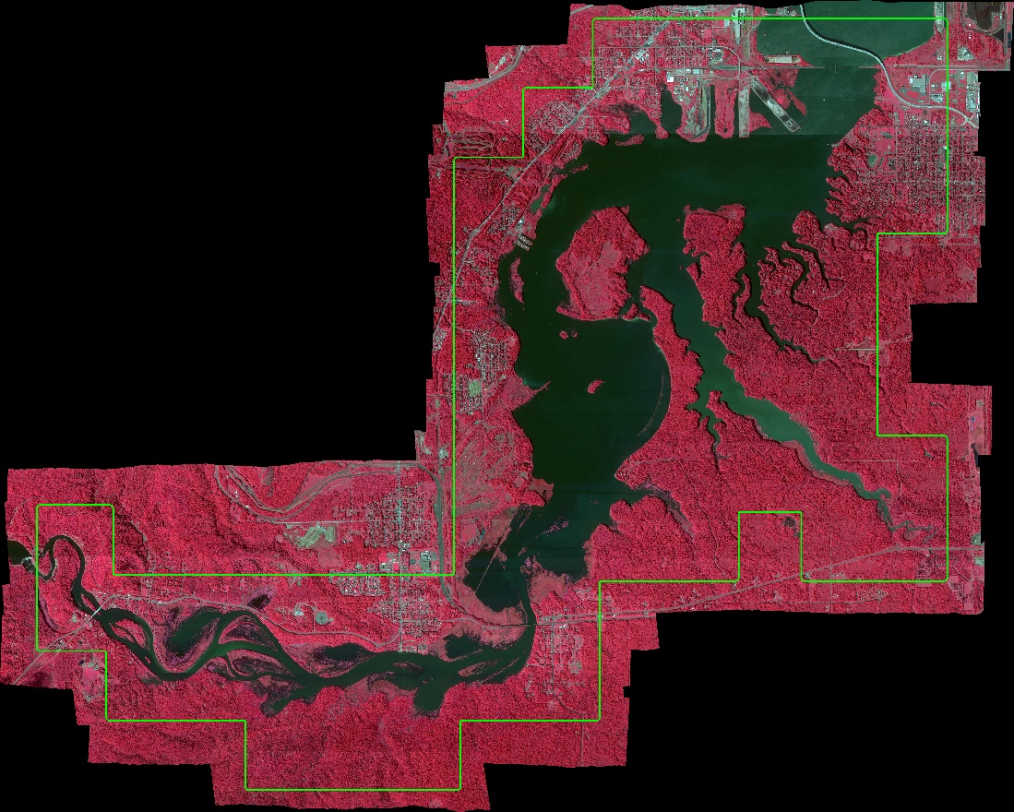
- 0903-1540
- 0903-1535
- 0901-1656
- 0901-1651
- 0901-1646
- 0901-1641
- 0901-1636
- 0901-1631
- 0901-1626
- 0901-1621
- 0901-1615
- 0901-1607
- 0901-1559
- 0901-1543
Image 6: St. Louis River Estuary CIR Mosaic
- 0901-1536
- 0901-1532
- 0903-1552
- 0903-1557
- 0903-1601 (Southernmost Line)

Image 7: St. Louis River Estuary LUT Mosaic

Site 3: Upper St. Louis River
All 16 flight lines covering the Upper St. Louis River site were collected on 3 Sept 2018 under clear conditions with no re-collections necessary.
- 0903-0943 (Northernmost)
- 0903-0947
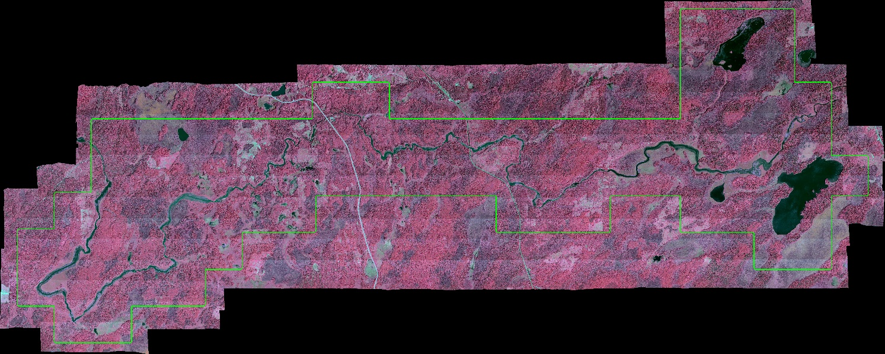
- 0903-0950
- 0903-0953
- 0903-1002
- 0903-1011
- 0903-1019
- 0903-1029
- 0903-1037
- 0903-1047
- 0903-1056
Image 8: Upper St. Louis River CIR Mosaic
- 0903-1106
- 0903-1115
- 0903-1129
- 0903-1133
- 0903-1136 (Southernmost)
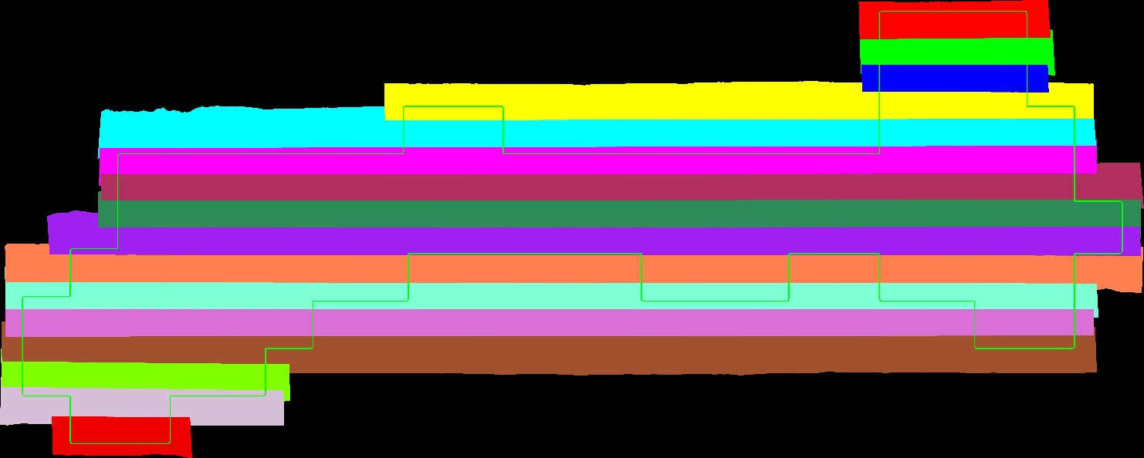

Image 9: Upper St. Louis River LUT Mosaic

Site 4: Bad River and Kakagon Sloughs

All 15 flight lines covering the Bad River and Kakagon Sloughs site were collected on 6 Sept 2018 under clear conditions with no re-collections necessary.
- 0906-0916 (Northernmost)
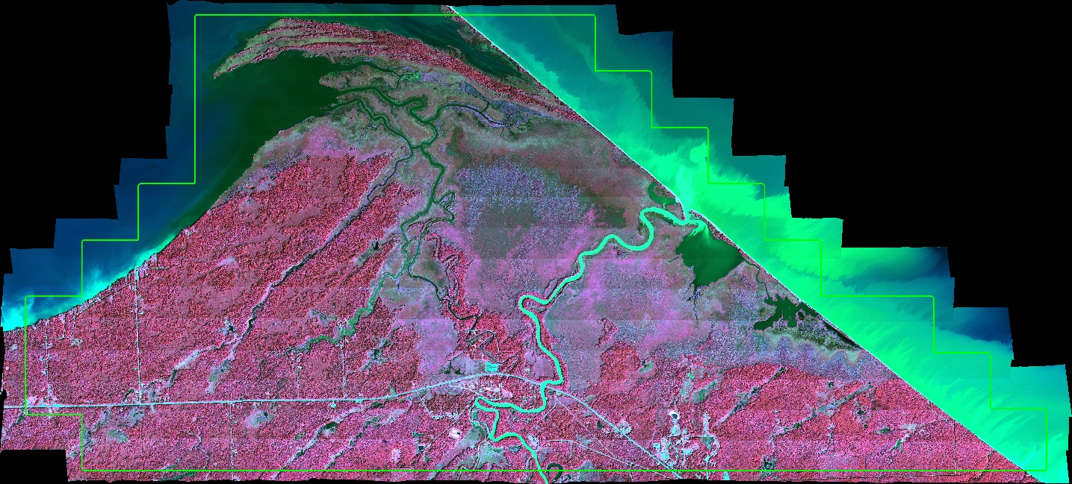
- 0906-0921
- 0906-0926
- 0906-0931
- 0906-0936
- 0906-0941
- 0906-0946
- 0906-0952
- 0906-1002
- 0906-1009
- 0906-1017
Image 10: Bad River and Kakagon Sloughs CIR Mosaic
- 0906-1024
- 0906-1032
- 0906-1040
- 0906-1048 (Southernmost)

Image 11: Bad River and Kakagon Sloughs LUT Mosaic

Site 5: Crooked Lake, Sucker Lake, and Ontonagon River
All 22 of the flight lines covering the Crooked Lake, Sucker Lake, and Ontonagon River site were collected on 6 Sept 2018 under clear conditions with no re-collections necessary.
- 0906-1332 (Northernmost)
- 0906-1324
- 0906-1316
- 0906-1307
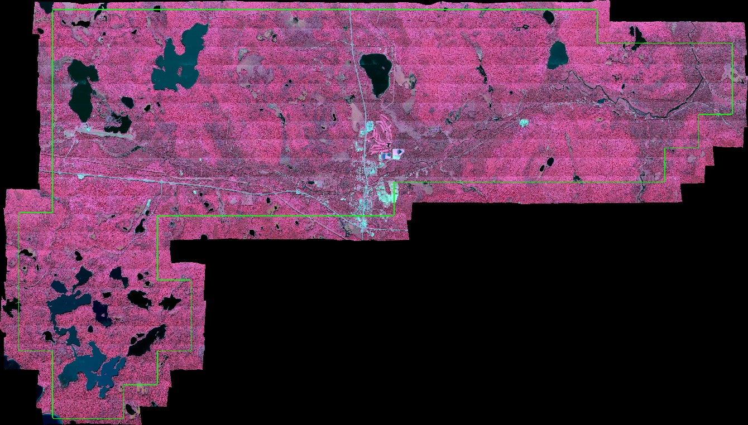
- 0906-1258
- 0906-1249
- 0906-1241
- 0906-1233
- 0906-1225
- 0906-1217
- 0906-1211
- 0906-1206
- 0906-1202
- 0906-1159
- 0906-1155
Image 12: Crooked Lake, Sucker Lake, and Ontonagon River CIR Mosaic
- 0906-1151
- 0906-1147
- 0906-1144
- 0906-1140
- 0906-1137
- 0906-1134
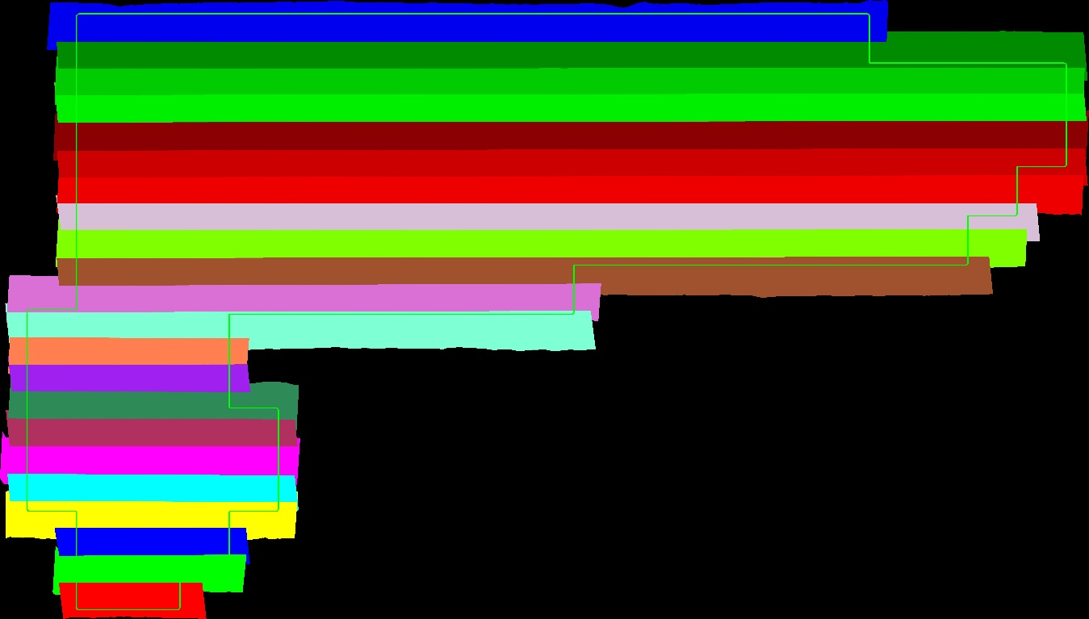
- 0906-1131 (Southernmost)

Image 13: Crooked Lake, Sucker Lake, and Ontonagon River LUT Mosaic

Site 6: Eastern Upper Peninsula
All 13 of the flight lines covering the Eastern Upper Peninsula Site were collected on 7 Sept 2018 under clear conditions with no re-collections necessary.
- 0907-1603 (Westernmost)
- 0907-1606
- 0907-1610
- 0907-1614
- 0907-1619
- 0907-1622
- 0907-1626
- 0907-1631
- 0907-1635
- 0907-1640
- 0907-1644
- 0907-1648
- 0907-1652 (Easternmost)
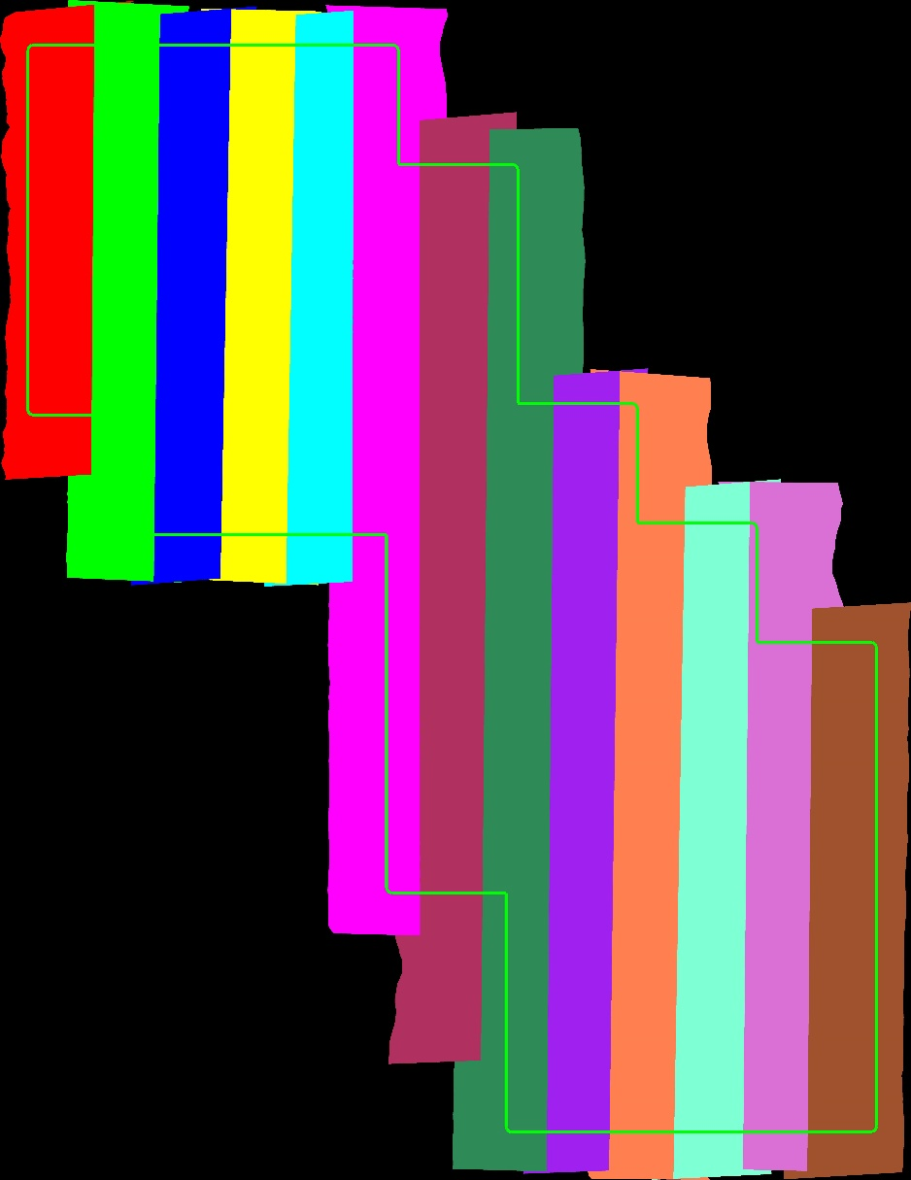
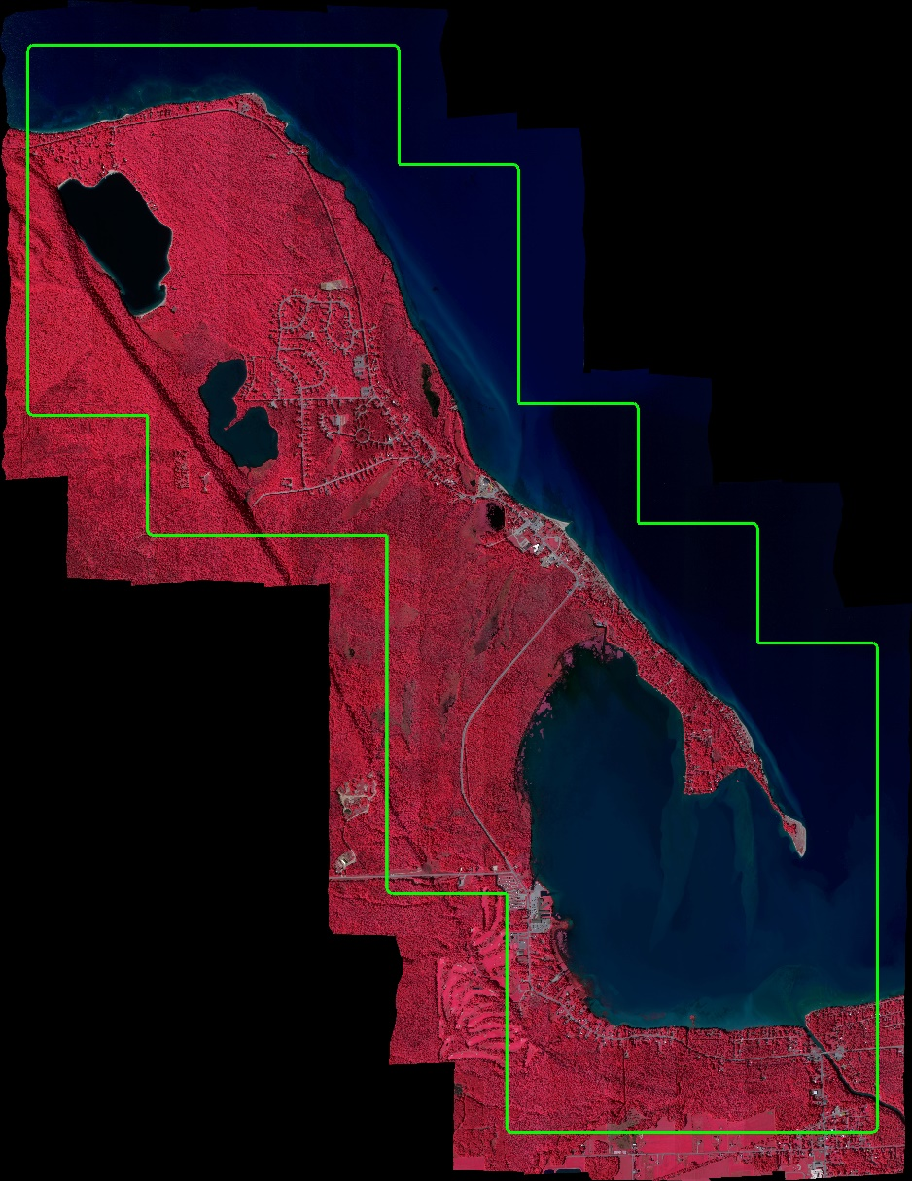

Image 15: Eastern Upper Peninsula LUT Mosaic
Image 14: Eastern Upper Peninsula CIR Mosaic

Data Processing and QC
As soon as the aircraft returned to base, Mr. Merrill made a copy of the raw data collected that day and began data processing on his field laptops using ENVI software and Galileo’s proprietary Project Manager software. The following steps detail the steps taken to pre-process the data.

Processing Level 1a – Radiometric Correction
- Dark Noise Removal
Dark image data was acquired for every raw image at the end of every flight line by the sensor control software closing the shutter and recording 5 seconds of dark noise. To remove sensor noise the mean value of every line of the dark data was subtracted from the corresponding line of the raw data (dark noise removal or dark current removal).

- Calibration from RAW data to radiance data using calibration file
After the dark noise removal, the raw data was calibrated to radiance units using a sensor specific calibration file. Every spatial and spectral pixel is multiplied with the corresponding value in the calibration file. The calibration values for each pixel on the CCD are calculated using an integrating sphere in the laboratory.
The radiance units are equal to (mW/cm^2*str*um)*1000.00.

- Smile Correction
Spectral smile is defined as changes in wavelength over the field of view (FOV). Smile correction was performed by proprietary algorithms.

- Crosstrack Correction

A crosstrack correction was performed using proprietary algorithm in order to normalize illumination in the across-track direction of each flight line.

- Quality Control
Quality control was accomplished using ASD measurements, established radiometric quality protocols and systematic manual evaluations.

Processing Level 1b – Atmospheric Correction
- Atmospheric Correction
The radiance units were converted to reflectance units using the ASD spectrometer measurements of uniform surfaces (parking lots, asphalt, sand and concrete) that were collected in the field. Multiple spectrometer measurements were taken at each site under clear conditions to ensure data quality. An “empirical line correction” method was used to calibrate every flight line to reflectance. After the correction an adaptive spectral filter was used to smooth the reflectance values and to eliminate outliers and spikes in the spectra.
The reflectance units are equal to Reflectance*10000.

- Quality Control
Quality control was accomplished using ASD spectrometer measurements, established atmospheric correction quality protocols and systematic manual evaluations.

Processing Level 2 – Geometric Correction
- Calculation of the sensor offset (Boresight correction)
During the aerial acquisition, four special Boresight flight lines were flown to geometrically calibrate the sensor and GPS/INS. The Boresight parameters were calculated using four overlapping flight lines flown in a crosshair pattern. 15 to 20 Ground Control Points per flight line pair (GCPs) were identified and used to calculate geometric correction values for Roll (0.162353), Pitch (0.131388) and Yaw (0.166983). These values were then used as input parameters for the geometric correction process.

- GPS/INS Data
The GPS/INS Data was encoded and processed for the use in the georectification process

- GLT files (Geographic Lookup Table)
A GLT file contains the geographic location of every pixel in the unrectified reflectance data. A GLT file was generated for every flight line using the GPS/INS Data, the Boresight Correction parameters and a Digital Elevation Model (DEM)

Processing Level 3 – Orthorectification
- Georectification using GLT data
The unrectified reflectance data was then georectified into North American Datum of 1983 (NAD83) and projected into the Universal Transverse Mercator (UTM) coordinate system using the corresponding GLT file. A DEM was used to correct for surface elevation variation across the scene.

- Quality Control
Geo-accuracy was checked and confirmed to meet quality pre-established quality standards by systematic comparison of specific geo-locations acquired in the field with a GPS unit and high resolution RGB imagery of known geo-accuracy.
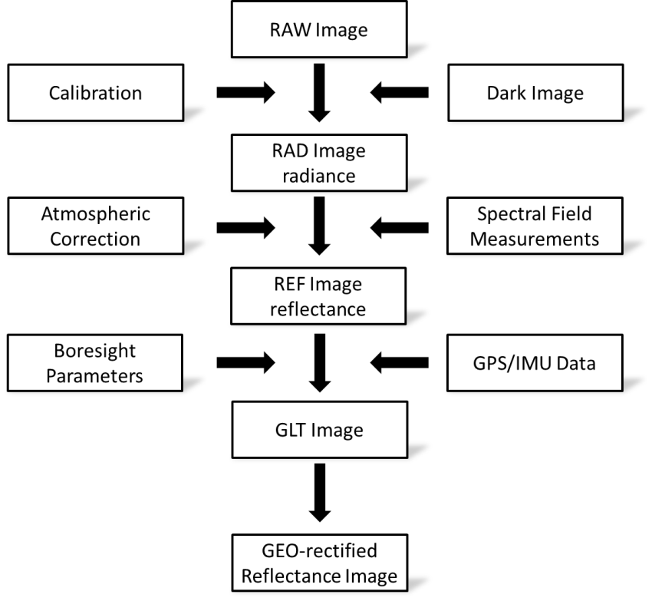

Figure 2, Sample of hyperspectral image processing

Appendix A

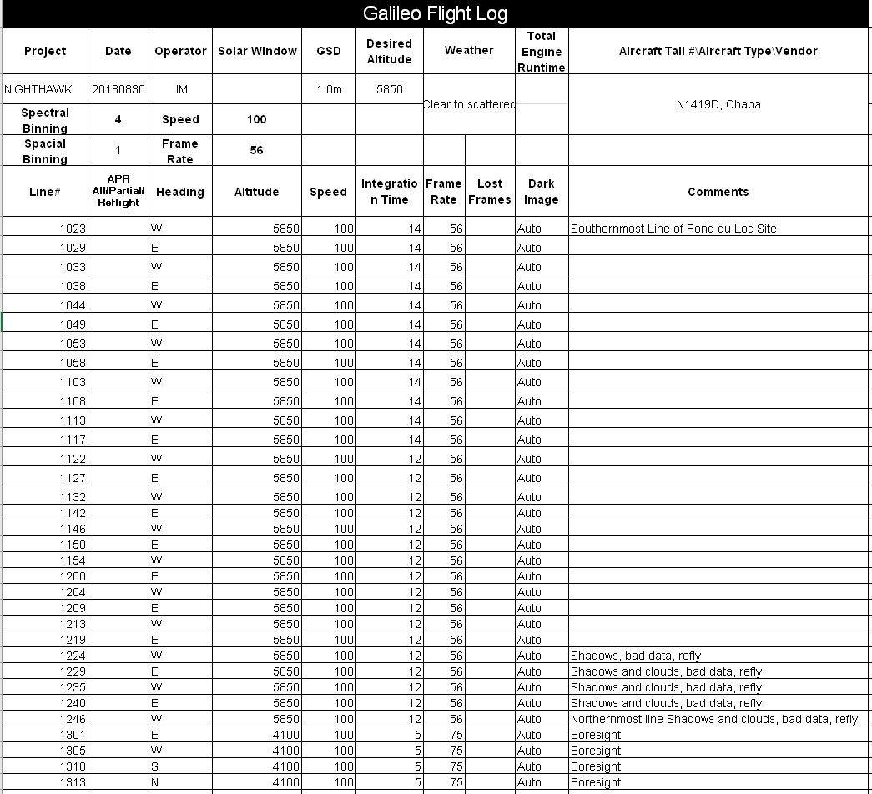
Image 16: 30 Aug 2018 Flight Log

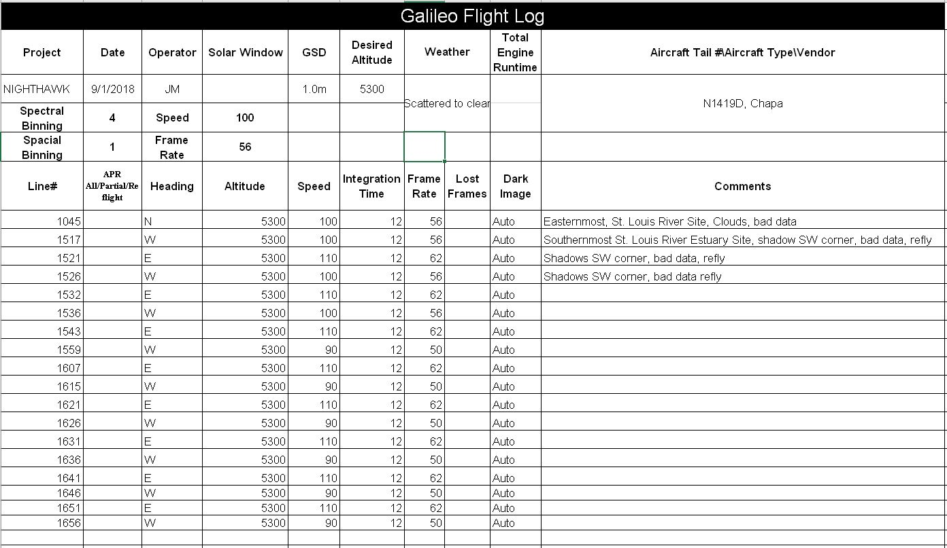
Image 17: 1 Sept 2018 Flight Log

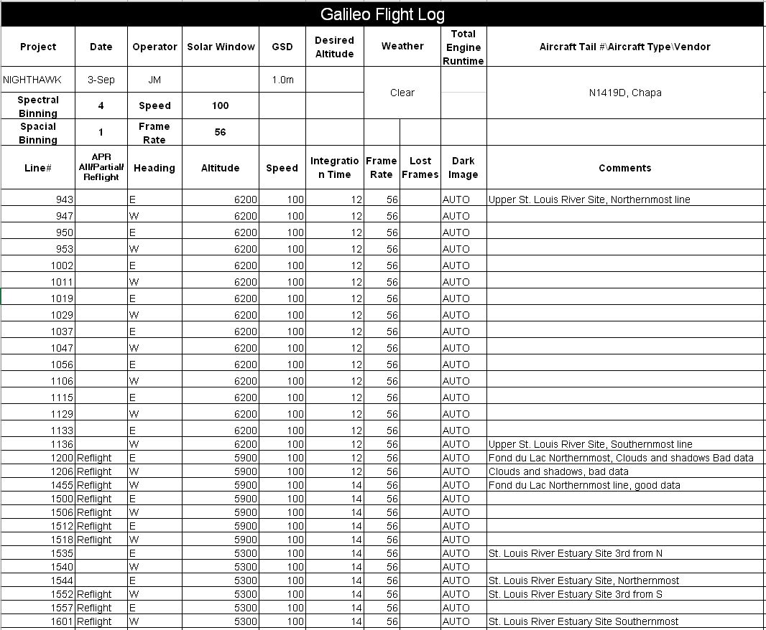
Image 18: 3 Sept 2018 Flight Log

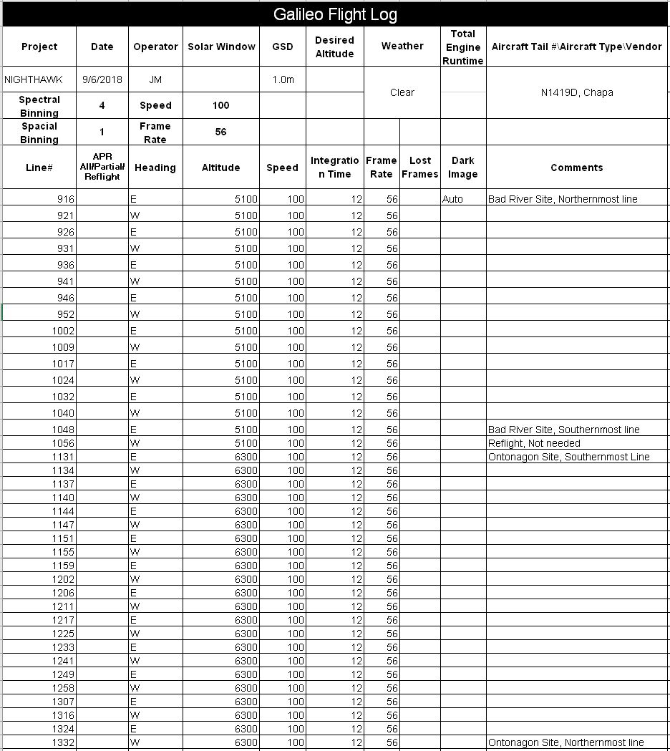
Image 19: 6 Sept 2018 Flight Log

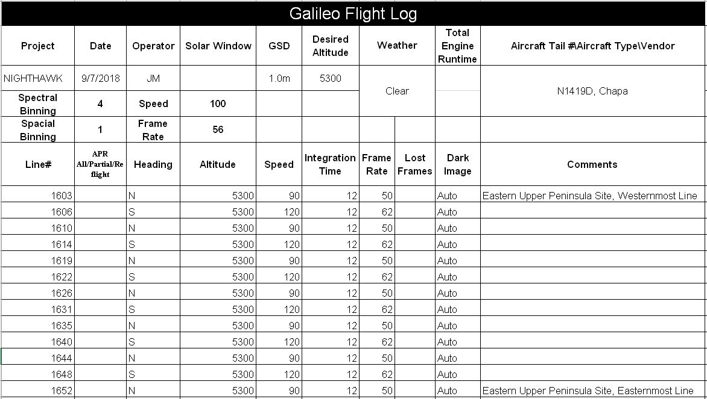
Image 20: 7 Sept 2018 Flight Log

Appendix B

AISA Eagle II Sensor Radiometric Calibration Coefficient and Radiance Sensitivity
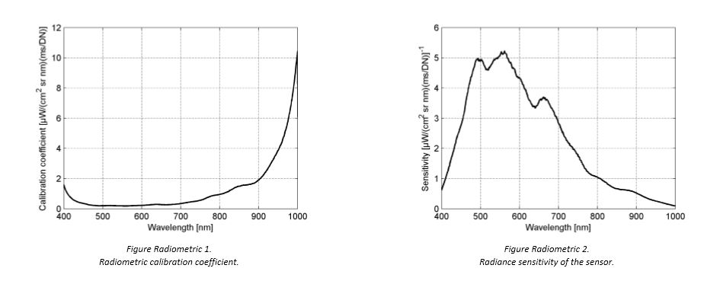

END

